How to Break Windows Administrator Password from DOS

Article Source: http://recoverlostpassword.com/article/break-windows-administrator-password-from-dos.html

A windows administrator account is a user account that gives full access to the machine. It is by far the number one target for someone trying to gain illegal access to your network and resource. So Administrators should change administrator password frequently to avoid unauthorized access to the domain or desktop machine.

Then something bad happens. Password can be easily forgot or lost. If you forgot windows administrator password, how could you break windows administrator password and gain access to your admin account?

Here is how to break windows administrator password from DOC command prompt
- Login as administrator or user account that has administrator privileges.
- Click Start -> Run

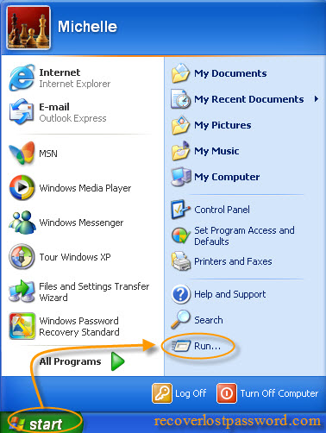
- Type CMD

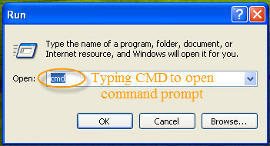
- Then the DOS shell screen will appear like below. Type “net user username password/domain” into the command prompt.

Replace username with the user account you login and the password with the new password you want to assign to that account. /domain is optional. If you are in a domain, specify the domain otherwise leave it.
- Once you click Enter, your password will be changed, like the example, the user will change the password of the user Michelle to 123456.

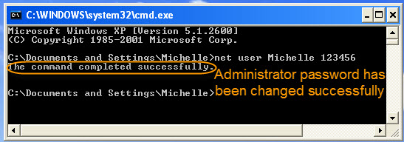

NOTE: If you do not have administrator rights on the machine, you will get the error message stating "System error 5 has occurred. Access is denied."

If you receive this error message that means you couldn’t break windows administrator password from DOC command prompt. At this time, SmartKey Windows Password Recovery comes in hands.

SmartKey Windows Password Recovery is a powerful password hacking which can help to break Windows administrator and domain password by burning a bootable Windows Password Reset CD/DVD or USB flash drive. With this bootable password reset cd, breaking windows admin password is a child’s job.

